**Deploying High Frequency Nitrogen Sensors to Guide Policy Development and Science in Portland, Maine**

A solution submitted to the Nutrient Sensor Action Challenge through challenge.gov

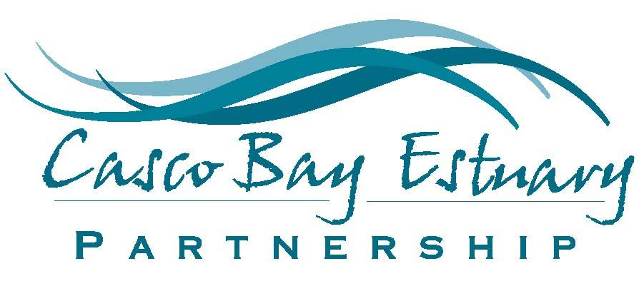

Team Lead: Curtis Bohlen

Director, Casco Bay Estuary Partnership

University of Southern Maine, P.O. Box 9300, Portland, Maine 04104

curtis.bohlen@maine.edu

cascobayestuary.org

September 20, 2017

Submitted on behalf of:

Casco Bay Estuary Partnership

Friends of Casco Bay

Maine Department of Environmental Protection

Portland Water District

University of Maine

University of Southern Maine

# A. Nutrient Issue

Casco Bay borders Portland and South Portland, Maine's principal economic and technological hub. The Casco Bay watershed region houses one quarter of Maine’s population and one third of the total jobs and economic output in the state. Although two thirds of the watershed remains forested, the most heavily developed portions of the watershed – about 10% of the landmass – border tributaries and the Bay itself, with extensive impervious surface (CBEP 2015). Numerous streams in the Casco Bay watershed are impaired due to stormwater from impervious cover. In Casco Bay’s marine waters, certain areas show signs of coastal eutrophication and hypoxia (CBEP 2015, CBEP 2016).

The source of concern about coastal eutrophication and hypoxia in Casco Bay is threefold: (1) elevated concentrations of nutrients, especially nitrogen, in portions of the Bay which may be beginning to experience negative impacts; (2) increasing human population in the region; and (3) increasing vulnerability of the Bay to the impacts of climate change.

Portland Harbor and the waters surrounding it have among the highest total nitrogen (TN) concentrations observed anywhere on the Maine coast, with median conditions exceeding 90% of coastal nitrogen measurements in Maine (Cadmus Group 2009; CBEP 2015). Recent evidence suggests that impacts from these high nitrogen loads are having increasingly negative consequences. Reports of algal overgrowth of tidal flats are more common (Miller 2016). High coastal nutrient concentrations may also be leading to coastally enhanced acidification due to algal growth (Cai et al. 2011). Data collected by Friends of Casco Bay shows acidified sediments in the region's tidal flats. Acidified coastal waters (below a pH of 7.4) are observed more than 10% of the time in 6 of 15 Casco Bay monitoring regions (CBEP 2015). The Maine legislature has formally recognized Casco Bay as a state-wide priority for addressing nutrient pollution and developing coastal nutrient criteria (Maine 123rd Legislature 2007).

Population growth in the Greater Portland area increases both point source and nonpoint source nitrogen loads to Casco Bay. Between 2000 and 2010, the population of communities that contribute to the watershed grew by 6.1 percent (CBEP 2015). Indeed, Portland had one of the highest growth rates of any city in the northeast in 2014 (Murphy 2015). Population is expected to increase significantly in coming decades. At present, neither of the region’s largest wastewater treatment plants is designed to remove nitrogen from the waste stream. The Portland Water District’s East End Wastewater Treatment Facility (the largest discharger in the state) will begin denitrification to reduce its nitrogen load by 20-40% over the next five years. The somewhat smaller South Portland facility will explore ways to optimize nitrogen removal over the same period. The EEWWTF is actively participating in monitoring and modeling efforts with researchers, and is a partner in the project proposed here. At present there are no regulatory restrictions specifically designed to reduce nutrient loading to the Bay from stormwater runoff or from agricultural non-point sources.

Climate change exacerbates the problems of high nitrogen loads. Over the past century, total precipitation and extreme storms in the region have increased (CBEP 2015). A recent study suggests that climate change in the northeast will increase nitrogen loading to coastal waters, exacerbating eutrophication (Sinha et al. 2017). Extreme storm events following periods of drought will likely increase the nutrient loads delivered to Casco Bay. For example, Portland still has 30 active combined sewer overflow (CSO) points that, in the drought year of 2016, discharged 318.4 million gallons of untreated wastes to Casco Bay and its tributaries (Riley 2017). In recent years, the Gulf of Maine has been warming faster than 99% of the world's oceans (Pershing 2015). Warmer waters both facilitate thermal stratification and increase respiration, thus increasing the risk of significant water quality problems (Rabelais et al. 2009).

In response to these increasing concerns, the past several years have seen emergence of new monitoring efforts and increased attention to nutrient issues in Casco Bay. These include: (1) focused attention on monitoring nutrients near Portland's East End; (2) the Sustainable Ecological Aquaculture Network (SEANET), which is studying Casco Bay's nutrient dynamics, productivity and respiration; (3) Gulf of Maine Research Institute's Casco Bay Aquatic System Survey (CBASS) looking at the biota; (4) establishment of three ocean acidification monitoring locations; (5) establishment of permanent eelgrass monitoring sites; and (6) creation of the Casco Bay Monitoring Network, which coordinates work among these multiple organizations. Use of high frequency nitrogen sensors will complement existing monitoring efforts, and help develop a robust monitoring framework, providing immediate practical application.

In addition to the expansion of monitoring, Maine's Department of Environmental Protection (DEP) has increased its attention to coastal nutrient pollution in Casco Bay, employing Reasonable Potential (RP) assessments. RP assessments use monitoring and modeling to assess whether nutrient discharges are likely to cause impairment of water quality. RP methodology is evolving as we learn more about nutrient dynamics in the region, especially how nutrient dynamics affect marine life and thus attainment of water quality standards.

In light of the multi-faceted emergence of nutrient management questions in the region, Casco Bay Estuary Partnership (CBEP) recently convened the Casco Bay Nutrient Council to identify strategies to reduce nutrient loads to Casco Bay. The Council, which brings together key decision-makers, scientists, and stakeholders, has been charged to work towards a shared understanding of nutrient challenges, and identify regional solutions. A robust understanding of the relative contributions of point versus non-point source nutrient pollution will be important as the Council considers alternative strategies to limit nutrient loads to the Bay.

In 2016, general concern about nutrients crystalized around specific needs for better understanding of nitrogen dynamics around the outfall of the EEWWTF. The East End plant is the largest single discharger in the state by volume and processes an average of 19.8 million gallons per day of wastewater. The plant is highly visible and it discharges into an area with important recreational (swimming beach; boat launch facilities), ecological (eelgrass; shorebirds, lobster), and economic (ferry, cruise ship, and oil terminals) resources. In 2017, the DEP, Friends of Casco Bay, the Portland Water District, and the University of Maine began coordinated research to better understand the sources and impacts of nutrient loading in the near and far field surrounding the EEWWTF.

Casco Bay has a diurnal tidal range on the order of three meters. The East End Plant is located in Maine's largest urban center, and at the mouth of the Presumpscot River. This is a complex hydrodynamic environment. Existing nutrient monitoring (relying on grab samples) lacks the temporal resolution to allow us to assess how water chemistry changes on small time scales. Time resolved data will allow us to correlate nitrogen concentrations with time-varying phenomena, such as tidal flux, precipitation, combined sewer overflow (CSO) events, and river discharge, thus helping clarify the relative contributions of different nutrient sources. In particular, these data will facilitate estimating non-point source nutrient loads to complement knowledge of point source loads, thus helping prioritize nutrient reduction strategies.

We propose to use high frequency nitrate plus nitrite data (NO2- + NO3-; informally referred to as "NOx" or "nitrate" in this proposal) collected near Portland's East End to (1) provide data applicable to evaluating the impact of the East End discharges on Casco Bay; (2) clarify the relative importance of riverine inputs, wastewater discharges, stormwater, and combined sewer overflows as sources of nutrients to the waters around Portland in alignment with the Casco Bay Nutrient Council; (3) support Maine DEP's RP analyses; (4) provide information on the range of nutrient concentrations experienced by eelgrass beds; and (5) provide data to support development of coupled hydrodynamic and ecosystem-based models of nutrient processes in Casco Bay.

# B. Team

## **Team Lead**

**Curtis C. Bohlen, Director, Casco Bay Estuary Partnership**. Dr. Bohlen has been Director of the Casco Bay Estuary Partnership for nine years. He coordinates both the Casco Bay Nutrient Council and the Casco Bay Monitoring Network. He will act as project coordinator, and ensure that results of the monitoring effort are shared with the team, the public, and policy makers. He will share responsibility for data management and QA/QC, prepare data summaries to facilitate policy discussions, and manage public dissemination of results via CBEP publications and website.

## **Team Members**

**Angela Brewer, Biologist III, Maine Department of Environmental Protection**. Brewer has been Maine DEP's lead on nutrient pollution investigations in coastal waters for seven years. She leads DEP's coastal monitoring efforts, including programs that track nutrients and eelgrass near Portland's East End. She will act as lead DEP scientist managing data collection efforts, and coordinate this project with other DEP monitoring and regulatory programs.

**Rob Mohlar, Senior Environmental Engineer, Maine Department of Environmental Protection.** Mohlar leads nutrient modeling for DEP, and will be responsible for integrating data with DEP's RP analyses.

**Mike Doan, Research Associate, Friends of Casco Bay**. Doan has nearly 20 years of experience managing water quality monitoring for FOCB, both managing FOCB water quality monitoring equipment and working closely with volunteers. He will manage Friends of Casco Bay's data collection in and around the East End, including collecting grab samples and assisting with sensor deployment and retrieval.

**Damian Brady,** **Assistant Professor of Marine Science and Assistant Director of Maine Sea Grant for Research, University of Maine**; Dr. Brady is an estuarine oceanographer who has worked on nutrient related issues in estuaries for the past 17 years and chairs the Chesapeake Research Council’s STAC committee reviewing the Chesapeake Bay Water Quality and Sediment Transport Model. Brady will manage all laboratory analyses of water samples, and lead equipment calibration and maintenance. He will also lead integration of data from this study with other data collection streams and ensure that these data are incorporated into development of hydrodynamic and ecosystem-based models. Dr. Brady leads the University of Maine’s Sustainable Ecological Aquaculture Research Theme pertaining to carrying capacity, and will work with the University of Maine’s Advanced Computing Group to archive, serve, and provide value-added tools to the data produced during this project. Recent examples of this capacity can be observed at maine.loboviz.com (providing real-time water quality data in four locations along the coast) and umaine.edu/coastalsat (providing up-to-date satellite derived chlorophyll, turbidity, and temperature for the coast of Maine).

**Scott Firmin, Director of Wastewater Services,** **Portland Water District.** Firmin will provide access to data on discharges and nutrient concentrations in the wastewater from the Portland Water District's EEWWTF. The district has also agreed to provide supplementary nutrient analyses through their water quality laboratory.

**Aaron Strong,** **Assistant Professor of Marine Policy, University of Maine**. Dr. Strong is a sustainability scientist with expertise in the use of new technological approaches to address coastal nutrient management and coastal acidification. Dr. Strong previously worked on the deployment of nutrient sensor technology to inform regional water quality decision-making and wastewater treatment plant permitting decisions in the San Francisco Bay Delta. Dr. Strong is also a member of the Maine Ocean and Coastal Acidification Partnership Steering Committee and the Northeast Coastal Acidification Network’s Policy Working Group, where he helps lead efforts to coordinate and expand regional acidification monitoring networks to provide use-inspired water quality data streams. Dr. Strong will assist the planning and coordination of communication and outreach and data management, and will help connect produced data to decision-makers and end-users, and the development of scenario-based regional nutrient models.

**Karen Wilson, Associate Research Professor, Department of Environmental Science and Policy, University of Southern Maine**. Dr. Wilson will provide access to her laboratory in Gorham, Maine and participate in equipment calibration and testing. The Gorham lab is significantly closer to the waters we will be studying than the University of Maine (UMaine) lab, thus allowing for faster redeployment of sensors.

**Luca Sanfilippo, Marketing Manager, Systea S.p.A**. Dr..Sanfilippo has submitted a letter expressing the Systea's willingness to assist us successfully deploy and test their technology.

**Alexander Beaton, Nitrate Sensor Technology Lead, Ocean Technology and Engineering Group, National Oceanography Center.** Dr. Beaton has submitted a letter promising to assist our team with deploying and testing the NOC nitrate sensor and provide advice and assistance to ensure that deployment and maintenance are performed properly.

# C. Current Monitoring

Friends of Casco Bay (FOCB) has, for 25 years, monitored water quality in Casco Bay. A description of FOCB's monitoring program is available on the FOCB website (<https://www.cascobay.org/water-quality-monitoring/>). Summaries of FOCB data are published every five years in CBEP's State of the Bay report (CBEP 2010, CBEP 2015). In 2017, a more intensive monitoring program was initiated adjacent to Portland's East End specifically to look at nutrient processes. The program, involving the Portland Water District, FOCB, Maine DEP, U.S. EPA, and the University of Maine, began studying nutrient processes near Portland's East End and in adjacent waters. The 2017 monitoring program will continue into 2018 and beyond. Current monitoring includes:

* Maine DEP and FOCB are collecting grab samples for nutrient analyses including ammonium (NH4), nitrate + nitrite (NOx) and total nitrogen (TN) at nine locations on each of six dates, along with a variety of ancillary data like temperature, salinity and dissolved oxygen (Figure 1).
* DEP deployed water quality sondes to gather time-resolved data on temperature, salinity, dissolved oxygen, and pH at two of those nine locations (Figure 1).
* University of Maine researchers are gathering data on nutrient concentrations and discharge from Casco Bay tributaries, including the Presumpscot River (which discharges to the tidal estuary in the center of Figure 1).

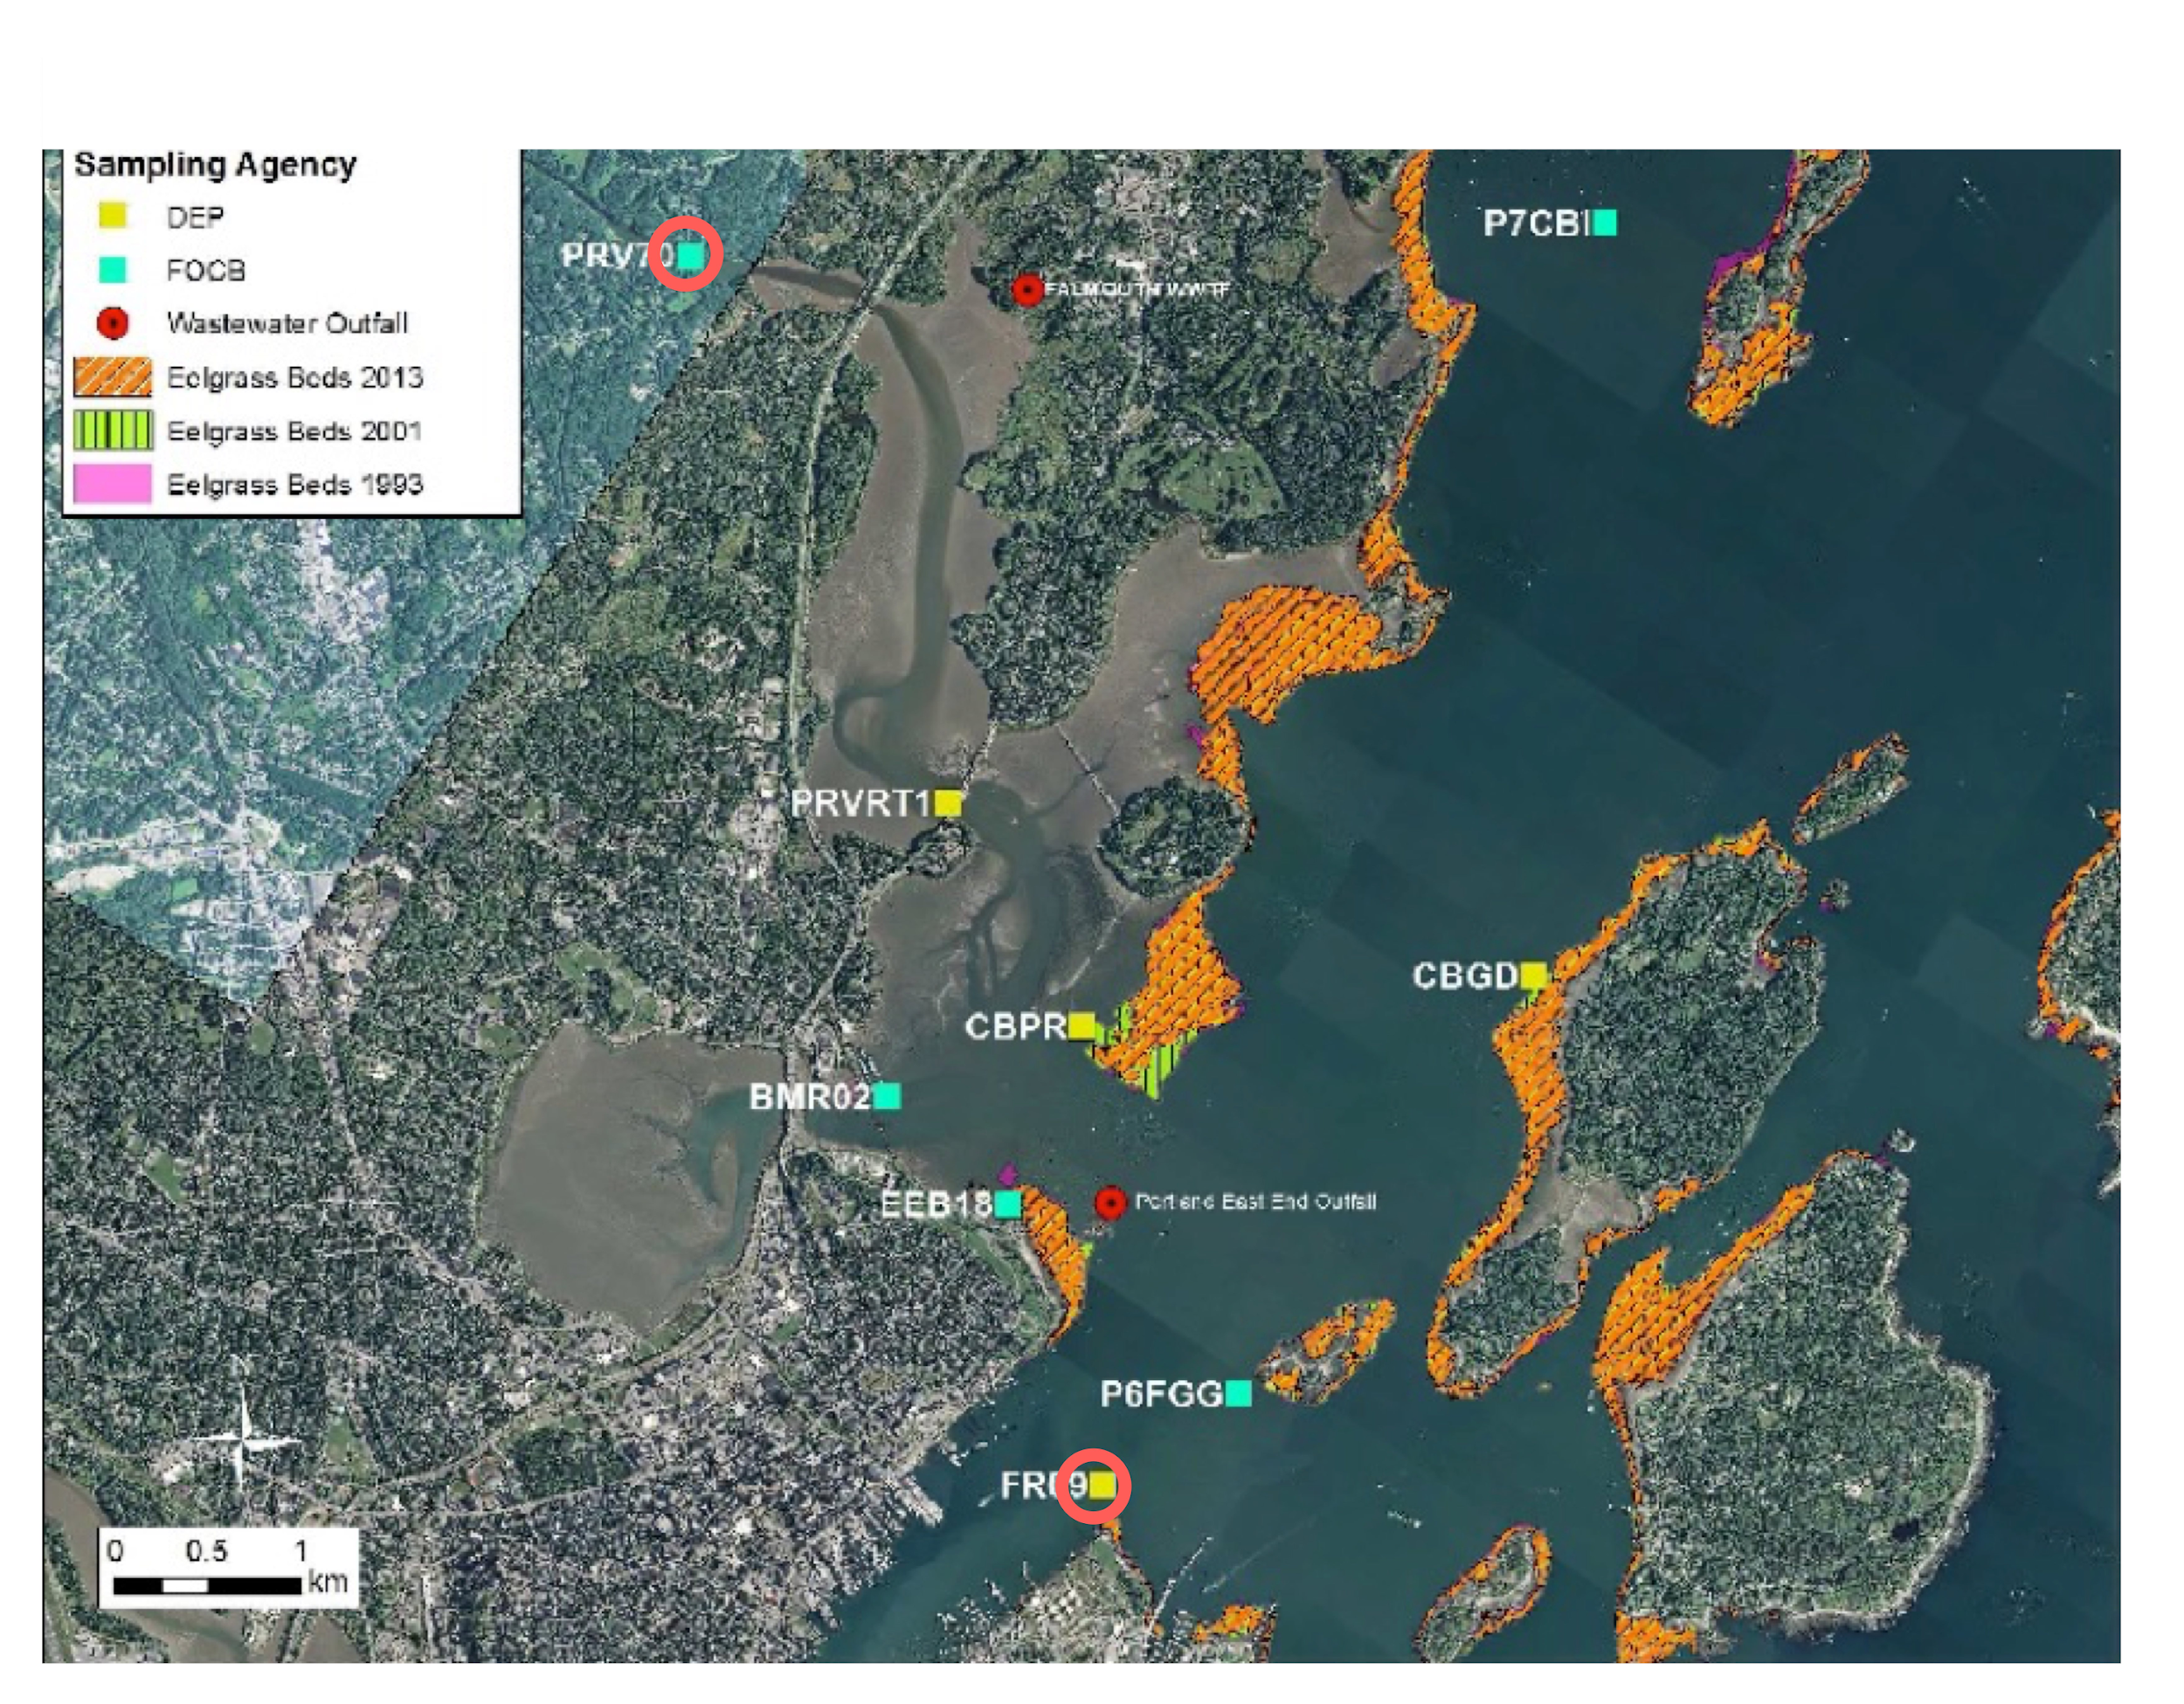

**Figure 1: 2017 East End Monitoring Nutrient Sampling Program.** Square symbols represent nine sites where grab samples were collected on six dates in 2017. Unattended monitoring using multiparameter sondes was conducted at the two locations circled in red. We anticipate deploying nutrient sensors at these same locations.

* The Portland Water District has intensified monitoring of wastewater nutrient concentrations and discharges.
* Laboratory nutrient analyses of samples (TN, NOx, NH4, and organic nitrogen by subtraction) are being conducted by The University of Maine BioGeoChemistry Laboratory (Dr. Brady’s Lab), which provides analytical support to academic researchers, private companies, nonprofit and governmental groups throughout the state.
* Four of the investigators on this proposal (Drs. Brady, Strong, Wilson and Bohlen), received a $100,000 award from the University of Maine System Research Reinvestment Fund in summer 2017 to use high frequency nitrate analyzers (Satlantic Submersible Ultraviolet Nitrate Analyzer (SUNA V2) and a Timberline Custom TL-2800 Single Channel Ammonia analyzer) in the Casco Bay system. The SUNA V2 and Timberline Ammonia instruments are designed to be continuously deployed on a small, moving vessel. When coupled with GPS technologies, the equipment provides snapshots of the distribution of nitrate and ammonia in shallow surface waters. The first deployment is scheduled for fall of 2017, and will continue in 2018.
* DEP facilitated acquisition of aerial imagery during June 2017 to enable mapping of eelgrass beds surrounding Portland’s East End wastewater outfall. Divers ground-truthed aerial imagery to determine deep edge locations and identify unknown subtidal signatures. Staff will delineate areal eelgrass extent and percent cover, and calculate interannual changes based on prior surveys.
* In early summer 2018, DEP will establish permanent eelgrass monitoring transects within four beds surrounding Portland's East End, document the position of the deep edge of the eelgrass beds, assess eelgrass health (density, presence of wasting disease and epiphyte load) , and collect data on light attenuation in the water column above the eelgrass beds. Aerial photography acquired in 2018 will enable additional interannual comparisons of changes in eelgrass areal distribution.

# D. Low-Cost High Frequency Sensors and Monitoring

We propose to deploy four low cost, high frequency nitrate sensors as a complement to other 2018 nutrient monitoring off of Portland's East End. We are focused on low-cost sensors for nitrate, as nitrogen is the most management-relevant nutrient in Casco Bay’s waters, and performance of low-cost ammonium sensors remains problematic. Adding fixed location, high frequency NOx measurements fills a key gap in current monitoring to validate and expand temporal data coverage. By coupling the nutrient sensors with an existing monitoring program, we minimize costs of managing the nutrient sensors, maximize use of complementary nutrient data to validate sensor data, increase the salience of data to decision-makers and help parameterize ecosystem models of nitrogen dynamics in Casco Bay. Partner organizations are already planning to have staff in the field collecting water quality samples, managing water quality sondes, and making observations of other environmental parameters. We will leverage those efforts to deploy, manage and retrieve nutrient sensors. The data from the nutrient sensors will be complemented by nutrient grab samples collected at nine sites in the region, and by synoptic maps of surface nutrient concentrations produced with UMaine's boat-mounted high throughput nutrient sensors. Sensors will be deployed at locations PRV70 and FR09 (Figure 1). The upstream site allows quantification of riverine inputs, while the marine location integrates inputs from the river, EEWWTF, and stormwater and CSO discharges from the Portland area. The data from the low-cost nutrient sensors provide high frequency measurements at fixed locations, while the other two data sources provide information on the spatial distribution of nutrients in surrounding waters.

To accomplish these monitoring objectives, we plan to deploy low-cost sensors from Systea and the National Oceanography Centre (NOC). Both companies have provided letters of support promising their assistance deploying their respective sensor technologies. These sensor systems are well suited for deployment in estuarine waters where low nitrate levels (< 0.05 mg/L-N) are common. **The Systea WIZ** probes will be deployed in a mono-parametric configuration to measure NO2 + NO3. The WIZ probe uses vanadium chloride reduction to reduce nitrates to nitrite and subsequent colorimetric methods to nitrite concentrations. (Alliance for Coastal Technologies 2017 - <http://www.act-us.info/Download/Evaluations/NextGenNutrient/SysteaNitrate/files/assets/common/downloads/publication.pdf>). The manufacturer's reported measurement range is 0.03 (MDL) to 16 μM (0.0004 to 0.23 mg/L-N). The **NOC Lab-on-Chip Nitrate Sensor** is a submersible wet chemical analyzer that measures total nitrate + nitrite (NO3-+ NO2-) on a microfluidic chip using the Griess assay and cadmium reduction. Each sample measurement is compared to a subsequent on-board standard measurement, thus eliminating drift problems. The measurement range is 0.03 to 1000 μM (0.0004 to 14 mg/L-N) (Alliance for Coastal Technologies - <http://www.act-us.info/Download/Evaluations/NextGenNutrient/NOCNitrate/files/assets/common/downloads/publication.pdf)>.

We propose to configure Systea and NOC sensors to collect NO3 concentration data every 60 minutes.[1] Field staff will visit each sensor a minimum of once every three weeks, to collect water samples for laboratory nutrient analyses, check on instrument function, download data, manage wastes, and remove biofouling. Although both sensor systems are capable of longer-term deployment, we anticipate issues with biofouling. A maximum three week deployment is prudent until we have better information on field performance in our waters. Furthermore, a three week deployment allows frequent cross-calibration with laboratory analyses to support data QA/QC.

# E. Data and Data Management

## 1. Solution Architecture

**Figure 2: Data Management.** Data downloaded in the field will be combined with results of analytic chemistry, and put through initial QA/QC checks by UMaine. Raw data will then be combined with ancillary data by CBEP to produce a provisional data set to be shared with partners. Partners will develop preliminary data products, and flag data inconsistencies. Final data QA/QC by UMaine will resolve inconsistencies and incorporate metadata. Final data will be shared with partners and made available to the public through the Maine Dataverse Network (MDVN), and public-facing data visualizations, through CBEP's website (light blue boxes).

Low-cost, high frequency sensors will be serviced in the field to the extent possible. At least twice over the course of the 2018 monitoring season, sensors will be retrieved and returned to the lab for cleanup, calibration, and maintenance. Calibration and post-calibration will be carried out in the lab following manufacturer's recommendations. In addition to traditional point sample calibration against laboratory analyses, measurements from the NOC and Systea instruments will be compared with data from the SUNA V2 optical sensor on the water. Sensors will be deployed with battery power, as neither of the proposed deployment locations are served by shore power. Sensors will be deployed at PRV70 off of floats. Sensors deployed near FR09 will be deployed from a buoy.

## 2. QA/QC

CBEP is a National Estuary Program, and all CBEP data collection programs are conducted under the auspices of an EPA-approved or Maine DEP-approved Quality Assurance Project Plan (QAPP). All primary partners on this project are familiar with collecting data under a QAPP. Data quality assurance will be carried out in a sequential manner. Data files will be archived before each QA/QC step.

1. Raw data from the nutrient sensors will be downloaded in the field, and maintained by the University of Maine.
2. Data will be checked using graphical and automated methods in WRDB 6.1 and R to identify impossible or unlikely values (outliers), and check for trends that may suggest instrumental drift.
3. Sensor data will be compared with laboratory analyses of grab samples collected adjacent to the sensors. Grab samples will be collected at the time of sensor deployment and at data retrieval. Data will be handled as follows (RPD = relative percent difference):

|  |  |
| --- | --- |
| Action | Criteria |
| Accept Data | RPD < 10% of lab values or  Absolute difference < 0.02 mg/L-N NOx |
| Flag Data | More than 10% but less than 20% of lab values |
| Reject Data | More than 20% |

1. If sensor drift is observed, an effort will be made to assess its cause and decide whether no action, a linear drift correction, or removal of suspect data is appropriate.
2. Data will be matched with ancillary data from other sources into a combined, provisional data set. The combined data set will include data from co-located data sondes, information on river discharge, tidal heights, etc. A final data QA/QC review will use graphical methods (in WRDB 6.1 and R) to evaluate relationships among major variables, and flag nutrient sensor readings that appear anomalous.
3. Provisional data will be shared with project partners, who will develop preliminary data summaries, visualizations, and graphics and report any data inconsistencies to CBEP and UMaine. Once potential problems are resolved, the data will be considered final, metadata will be added, and the data submitted to the Maine Dataverse Network (MDVN) and all partners.
4. All data anomalies and their resolution will be logged in a QA/QC log.

## 3. Data Sharing

All data sharing will conform to the Open Geospatial Consortium data standards. Additionally, the management of these data and model products will be based on the end-to-end data management lifecycle prescribed in the NOAA Management of Environmental Data and Information Guidelines. Specifically, we will: (1) *Determine what environmental data are required to be preserved for the long term and how preservation will be accomplished.* The primary tool for data retention on this project is the MDVN. The MDVN is a public repository, which runs on secure servers hosted and maintained by the Advanced Computing Group at the University of Maine. Data will be retained indefinitely. (2) *Conduct scientific data stewardship to address data content and access.* MDVN allows for the flexibility to serve potential users and demonstrate data stewardship by way of version control, terms of use agreements, and permissions. (3) *Enable integration and/or interoperability with other information and products*. In addition to data sharing features, MDVN includes a suite of visualization tools, persistent data citations, and the ability to embed on websites. Multiple project partners will also develop data visualization, outreach, and communication products based on these data (see below). Ultimately, the data will be used in several regulatory and policy-relevant contexts (point- and non-point source management).

## 4. Metadata

*Developing and maintaining metadata throughout the environmental data lifecycle that comply with standards:* Immediately after collection, data will be converted to OpenDAP or CSV formats. These formats are fully supported by MDVN, which performs archival format migration, metadata extraction,; and validity checks. Deposit in these formats will enable on-line analysis, variable-level search, data extraction and re-formatting, and other enhanced access capabilities. The MDVN repository system's “templating” feature will be used for consistency of model output across studies. The MDVN system automatically generates persistent identifiers, and Universal Numeric Fingerprints (UNF) for studies; extracts and indexes variable descriptions, missing-value codes and labels; creates variable-level summary statistics; and facilitates open distribution of metadata with a variety of standard formats (DDI v 2.0, Dublin Core, and MARC) and protocols (OAI-PMH and Z39.50).

In addition, final data will be accompanied by plain-language reports, fact sheets and web content aimed at non-specialists. Quality Assurance Project Plans (which include numerous details about data generation) will also accompany the data. These supplementary written materials provide an important complement to formal metadata, especially for non-specialists.

# F. Analytics and Interpretation

Scientists, regulators, and interest groups in the Casco Bay region have a long history of working together to share and understand water quality monitoring data. Our team involves individuals and organizations with complementary data analysis skills and goals. Data analysis will proceed along several different tracks, under leadership of different organizations, producing shared and public products optimized for different data end-users and target audiences.

1. **Public visualizations (UMaine).** The University of Maine and Maine Sea Grant have a long history of providing derived products from research to the public, including the Gulf of Maine Ocean Observing System (GoMOOS), new products currently maintained in the Sustainable Ecological Aquaculture Network (SEANET; maine.loboviz.com), and Maine Sea Grant’s Signs of the Season (<https://www.seagrant.umaine.edu/education/signs-of-the-seasons)>. We propose to use the University of Maine and Maine Sea Grant’s communication and IT infrastructure to serve nitrogen data to the public – including public meetings, workshops, and public interactive visualization exhibits – while also providing management context.
2. **Data summaries for decision-makers (CBEP).** CBEP will summarize results to share with the Casco Bay Nutrient Council, a group of key nutrient stakeholders and decision-makers. Analysis will emphasize variation in observed nutrient concentrations and bivariate relationships between nutrients and time-varying phenomena, including precipitation, wastewater, combined sewer overflow and river discharges, and tidal stage. Statistical modeling will emphasize use of generalized linear models, time series analysis and non-parametric methods. Data analysis will be conducted using R via RStudio. Exploratory data analysis and generation of products will be documented in R Notebooks, which allow encapsulation of analytic steps, results and explanatory narrative into one document.
3. **Calibration/verification of predictive modeling (Maine DEP).** DEP will use the data to inform modeling efforts associated with the fate and transport of specific nutrient loads in Casco Bay. Accurate modeling is an essential component of an effective regulatory framework to address the potential need for discharge limits under an RP analysis.
4. **Incorporation of data with hydrodynamic and ecosystem models (UMaine).** Data generated from sensor deployments will be used to parameterize a coupled hydrodynamic and ecosystem model of Casco Bay in Dr. Brady’s research group, using the Finite Value Community Ocean Model (FVCOM) platform. Ultimately, data generated will be used to develop a scenario-planning model that incorporates increased population pressures, increases in surface and bottom water temperature, and increases in extreme precipitation effects to model nutrient dynamics and the risk of eutrophication under future conditions of social and environmental change.

# G. Communication and Use

A central purpose of the project is to share results with a variety of audiences, from the general public, to key decision makers, to academic scientists.

**Target Audience: General Public**

1. Data visualizations based on provisional data will be posted to the CBEP website following each data download (4 to 7 times in 2018, beginning in June 2018).
2. An interactive data visualization will be deployed by UMaine by the end of 2018.
3. CBEP will produce a fact sheet by end of 2018 summarizing the project and its findings.

**Target audience: Decision makers and the coastal community**

1. Results will be presented to the Casco Bay Nutrient Council, in fall of 2018, and shared with local officials and other water quality stakeholders via workshops and presentations through winter of 2019.
2. A formal written report will be prepared for the Council by end of 2017, disseminated to water quality stakeholders not on the Council, and made available to the public.

**Target audience: Scientists and Regulatory Agencies**

1. Results and data will be shared with the Casco Bay Monitoring Network (fall 2018).
2. Final data and complete metadata will be released via the MDVN (December 2018).
3. Data will be used to help develop ecosystem-based models of Casco Bay (2019).
4. The data will be used to support DEP's RP Analyses within waste discharge licenses, which will assist with identifying need for nutrient load reductions (ongoing).
5. Characterization of typical nutrient conditions and documentation of weather events resulting in anomalous nutrient conditions will facilitate DEP water quality standards attainment decisions with regards to potential impacts on marine life (ongoing).
6. The data will be used in support of academic papers, presentations at professional meetings, and student research projects through ties to University of Maine and University of Southern Maine (ongoing).

# Bibliography

Cadmus group and Saquish Scientific. 2009. Nutrient Criteria Development in Maine Coastal Waters: Review of Existing Data and Preliminary Statistical Analyses. Augusta, ME: Maine Department of Environmental Protection. <http://www.maine.gov/dep/water/nutrient-criteria/091104_cadmus_saquish_nutrient_criteria_report.pdf>

CBEP (Casco Bay Estuary Partnership). 2010. 2010 State of the Bay Report. Portland, ME. <http://www.cascobayestuary.org/publication/2010-state-bay-report/>

CBEP (Casco Bay Estuary Partnership). 2015. State of the Bay 2015 Report. Portland, ME. <http://www.cascobayestuary.org/wp-content/uploads/2015/10/Indicator_ClimateChange.pdf>

CBEP (Casco Bay Estuary Partnership). 2015. Casco Bay Plan 2016-2021. . Portland, ME. <http://www.cascobayestuary.org/wp-content/uploads/2014/06/Casco-Bay-Plan-2016-2021-Casco-Bay-Estuary-Partnership.pdf>

Cai, W. J., Hu, X., Huang, W. J., Murrell, M. C., Lehrter, J. C., Lohrenz, S. E & Zhao, P. 2011. Acidification of subsurface coastal waters enhanced by eutrophication. Nature Geoscience, *4*(11), 766-770.

MCBER (Maine Center for Business and Economic Research) and rbouvier consulting. In Press. The Economic Contribution of Casco Bay. Casco Bay Estuary Partnership. Portland Maine.

Maine 123rd Legislature. 2007. Resolve, Regarding Measures To Ensure the Continued Health and Commercial Viability of Maine's Seacoast by Establishing Nutrient Criteria for Coastal Waters. RESOLVE Chapter 49 LD 1297, item 1, 123rd Maine State Legislature. <http://www.mainelegislature.org/legis/bills/bills_123rd/chappdfs/RESOLVE49.pdf>

Miller, K. 2016. Green slime points to pollution of Casco Bay. Portland Press Herald August 7, 2016. <http://www.pressherald.com/2016/08/07/green-slime-points-to-pollution-of-casco-bay/>.

Murphy, E.D. 2015. Population gains put Portland metro area in No. 2 spot in New England. Portland Press Herald March 26, 2015. <http://www.pressherald.com/2015/03/26/population-gains-put-portland-metro-area-in-no-2-spot-in-new-england/>.

OPM (Office of Policy and Management). 2016. Maine demographic projections. Augusta, ME. <http://maine.gov/economist/projections/index.shtml>. Accessed August 24, 2017

OPM (Office of Policy and Management). 2016. Maine population outlook 2034. Governor's Office of Policy and Management. Augusta, ME. <http://maine.gov/economist/projections/pub/Population%20Outlook%20to%202034.pdf>. Accessed August 24, 2017.

Pershing, A.J., M.A. Alexander, C.M. Hernandez, L.A. Kerr, A. Le Bris, K.E. Mills, J.A. Nye, N.R. Record, H.A. Scannell, J.D. Scott, G.D. Sherwood, and A.C. Thomas. 2015. Slow adaptation in the face of rapid warming leads to collapse of the Gulf of Maine cod fishery. Science 350(6262):809-812

Rabalais, N.N., R.E.Turner, R.J. Díaz, and D. Justić. 2009. Global change and eutrophication of coastal waters. ICES Journal of Marine Science, 66(7):1528–1537. <https://doi.org/10.1093/icesjms/fsp047>

Riley, 2017. Maine Combined Sewer Overflow 2016 Status Report. Maine Department of Environmental Protection. Augusta, ME <http://www.maine.gov/dep/water/cso/2016_status_report.pdf>.

Sinha, E., A.M. Michalak, and V. Balaji. 2017. Eutrophication will increase during the 21st century as a result of precipitation changes. Science 357, 405–408.

1. The Systea sensor's technical specifications suggest a minimum cycle time of 40 minutes.